**Capstone project**

**Sport Analytics**

**Report**

**BY**

**MOHAMED ASRAR ALI S**

**Project Overview**

Title: Sports Analytics: Insights into Olympic Games

Objective:  
To analyze Olympic Games data using Power BI, identify historical trends, explore participation patterns, and evaluate medal distributions across regions, sports, and gender. The project aims to deliver actionable insights for understanding the growth and diversity of the Olympics.

**Project Steps**

1. Data Preparation

* Import datasets related to cities, games, sports, events, participants, and medals.
* Clean and validate data for completeness and accuracy.
* Establish relationships between tables:
  + Link participants to regions, games, and events.
  + Connect medals to events, regions, and participants.

2. Data Modeling

* Build a relational data model in Power BI:
  + Ensure one-to-many relationships for tables like games, sports, events, and medals.
  + Define bi-directional relationships where cross-filtering is necessary.

3. DAX Measure Creation

* Write DAX measures for key calculations, such as:
  + Total medal counts.
  + Participant growth over time.
  + Event distributions by gender and season.

4. Visualization Development

* Design Power BI dashboard pages with interactive visualizations for each analytical question:
  + Historical Trends.
  + Regional Participation.
  + Gender Representation.
  + Sports and Medal Insights.

5. Testing and Validation

* Validate visualizations for accuracy and responsiveness.
* Test slicers and filters for interactivity.

6. Presentation and Reporting

* Compile insights into a PowerPoint presentation:
  + Use visual aids like charts and tables to present findings.
  + Summarize key insights and recommendations.

**Data Schema Overview:**

* + - * **City Table:** It contains types of cities and their id’s.
      * **Games Table:** It contains games year, seasons, games id, games name.
      * **Event Table:** It contains event id, sport id, event name.
      * **Medal Table:** It contains medal name, medal id.
      * **Sport Table:** It contains sport name, sport id.
      * **Competitor-event Table:** It contains competitor id, event id, medal id.
      * **Games-competitor Table:** It contains city id, game id.
      * **Games-city Table:** It containsAge, age distribution, game id, city id.
      * **Person Table:** It contains Full name, Height, Weight, id, Gender.
      * **Noc person Table:** It contains id, noc, region name.
      * **Person-Region Table:** It contains person id, region id.

**ER Diagram**

**Power BI problem Statement**

**1.How many Olympic Games have been held in each season (Summer vs. Winter)?**

Conclusion:

In each Olympic games , in summer there are 29 games and in winter there are 22 games.

**Conclusion:**

**In each Olympic games , in summer there are 29 games and in winter there are 22 games.**2.What is the distribution of games across different decades?

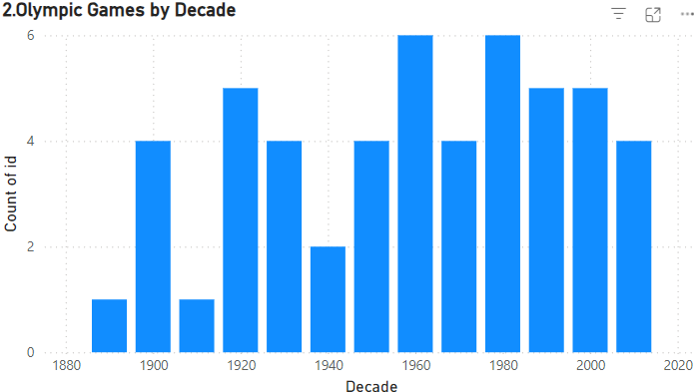

Conclusion:

The Olympic games are at its peak in the year 1960 and 1980 and little slow in its earlier years like 1880 and 1900.

3.Which cities have hosted the most Olympic Games?

Conclusion

London (3 times),Athina(3 times), Paris (2 times), Los Angeles (2 times).

Cities in developed nations dominate hosting frequency

4.What is the distribution of sports between Summer and Winter Olympics?

Conclusion

IN Olympics games summer season has more distribution of games then winter that is in summer there are 52 sports and in winter there are 17 sports

5.Which sports have the highest number of events in the Olympics?

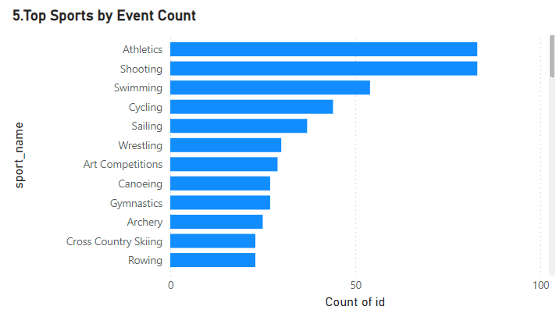

Conclusion

Sports like Athletics and shooting,swimming held more number of event in Olympic games.

6.How has the participation in each sport evolved over time?

Conclusion:

Consistent growth in traditional sports; new sports like Golf and Tennis.

The participants trends of sports increased over year to year.

7.How many events are there in each sport?

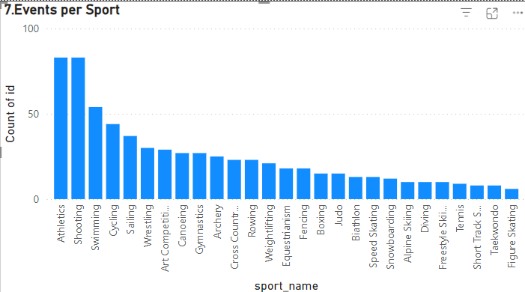

Conclusion:

sports like atheletics , shootingand swimming has more number of event in Olympic games then others

sports like taekwondo , alpine skiing has less number of event in Olympic games.

8.What is the distribution of events by gender (Men, Women, Mixed)?

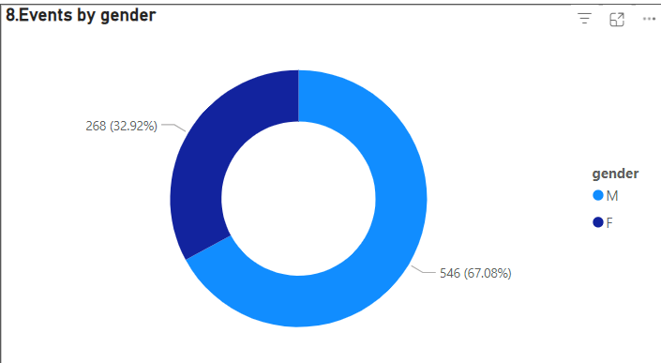

Conclusion:

Mens have participated in more events than womens in Olympic games.  
 Mens participated in 546 events while womens participated in 268 events

9.How has the number of events changed over time?

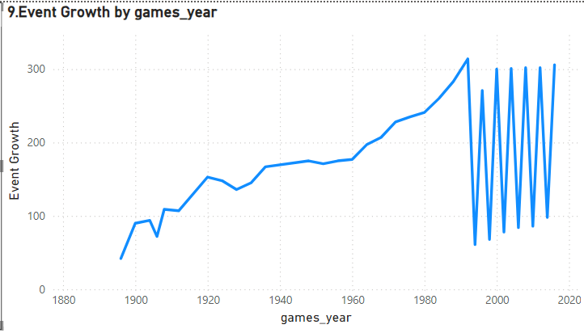

Conclusion

In Olympic games number of events are increases over years rapidlty. And after 1980 the number of events are not constant it varies up and down.

10.What is the distribution of participants by gender?

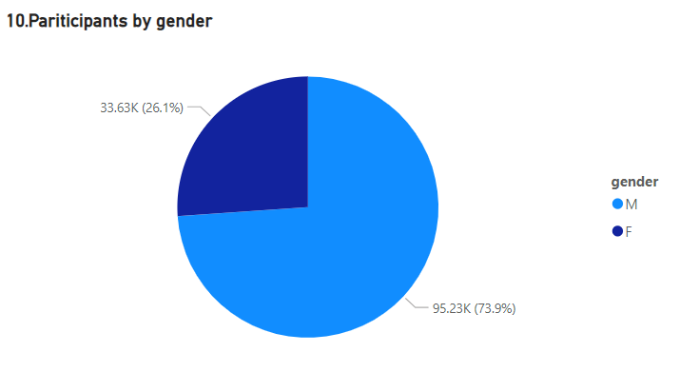

Conclusion:

The participants in Olympic games are mostly males compare to females.

The total number of participants of males are 95.23k and females are 33.63k.

11.Which countries have the highest number of participants in the Olympics?

Conclusion:

Countries like USA,UK,France etc has highest number of participants in Olympic games.

Countries like Haiti,guam,Guyana hs least numbers of participants ion Olympic games.

12.How does the age distribution of participants vary across different games?

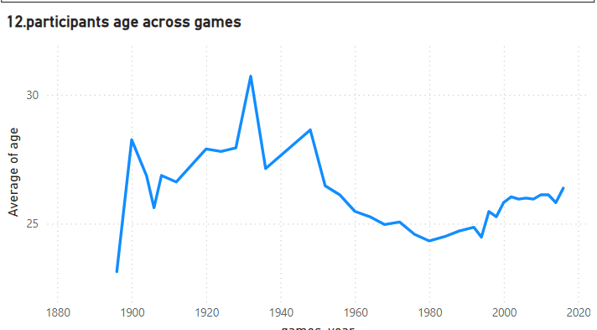

Conclusion:

Participants age varies across years in Olympic games.

In 1920 to1940 there is highest age participants while after 2000 the age is between 24 to 27.

13.How many medals have been awarded in each Olympics?

Conclusion:

In 1992,1988,2000 there are large number of awards are awarded in Olympic games.

In 1896,1906,2002 there are less number of awards are awarded in Olympics games.

14.Which countries have the highest number of gold medals?

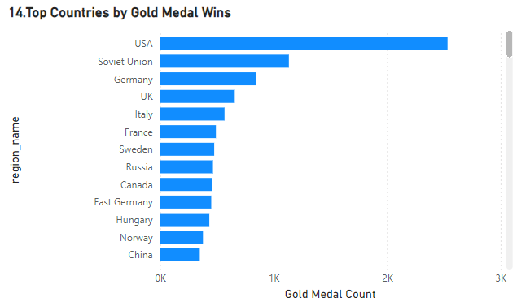

Conclusion:

Countries like USA,Soviet Union ,Germany has received more number of Gold medal.

Countries like Turkey,South Africa,Mexico has received less number of gold medal.

15.How does the medal distribution vary across different sports?

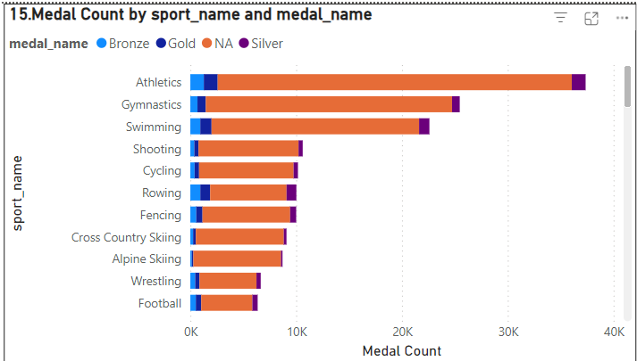

Conclusion:

Sports like Athletics , Gymnastics has more medals than other games.

16.How many regions or NOCs participate in each Olympic Games?

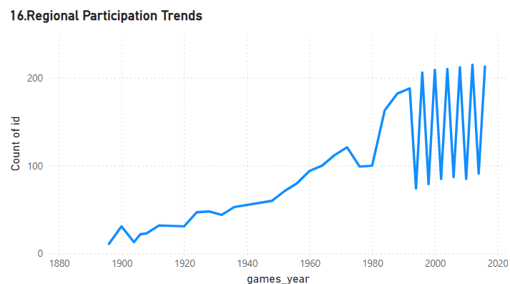

Conclusion:

Region wise participants are increased through the year and it is not stable after 1990.

17.Which regions have the highest number of participants in the Olympics?

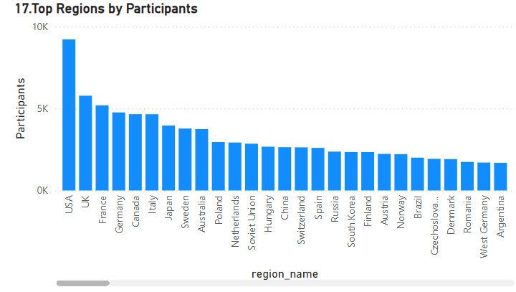

Conclusion:

Countries like USA , UK has highest regions by participants.

Countries like Fiji, cyprus , Zambia has least regions by participants.

18.What is the distribution of medals among different regions?

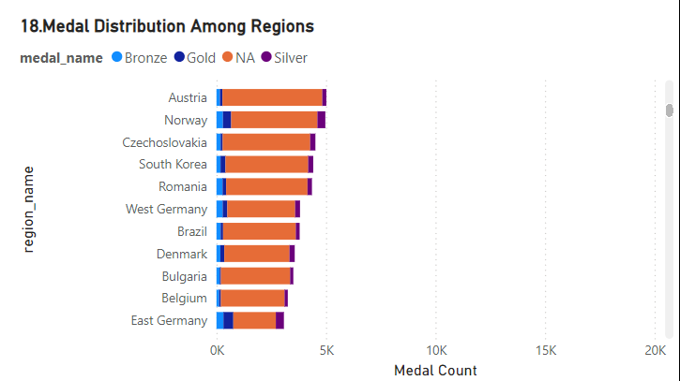

Conclusion:

Countries like Austria , Norway ,Romania has high medal distribution across the region.

**EDA Analysis**

1. Are there any trends or patterns in the frequency of hosting Olympic Games?

Conclusion:

Some cities, like **London, Athina ,** **Los Angeles**, and **Paris**, have hosted multiple times, indicating their prominence in global sports infrastructure and historical significance.

Hosting was more frequent in Europe during the early 20th century, with a gradual shift to other continents in the 21st century.

Countries in **Europe** and **North America** dominate hosting frequency.

2.How has the duration of Olympic Games changed over time?

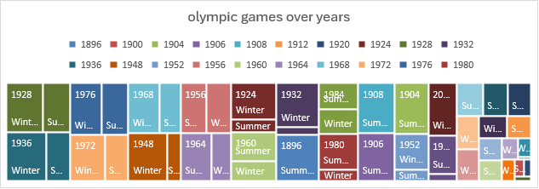

Conclusion:

Most recent games typically last **15-17 days**, allowing for a **two-week format** aligned with global broadcasting schedules.

The **1908 London Olympics** lasted 187 days due to event spread.

The **2020 Tokyo Games** faced delays and challenges from the COVID-19 pandemic, but the duration of events remained similar.

Winter Games also follow a similar pattern, typically lasting **14-16 days**.

3.Are there any notable events or occurrences associated with specific Olympic Games?

Conclusion:

Number of participants varies across all the Olypimcs due to various reasons.

The Olympic Games have witnessed numerous notable events and occurrences that have shaped history. These include record-breaking performances, moments of political significance, groundbreaking inclusions (e.g., gender equality milestones), and technological innovations. Each edition of the Games reflects a unique intersection of sports, culture, and societal change, leaving a lasting legacy on the global stage.

4.Are there any emerging sports that have been recently added to the Olympics?

Conclusion:

Games like Gymnastics,Badminton etc are recently added games.These additions reflect the evolving interests of younger audiences and global sports culture, ensuring the Olympics stay relevant and inclusive in the modern era.

5.How has the popularity of certain sports changed over the years?

Conclusion:

Number of participants increased in games like Gymnastics,Athletics,Swimming over years.Traditional sports like athletics and swimming remain popular, while newer sports such as e-sports and extreme sports are gaining traction, reflecting shifting audience preferences globally.

6.Are there any sports that are specific to a particular region or culture?

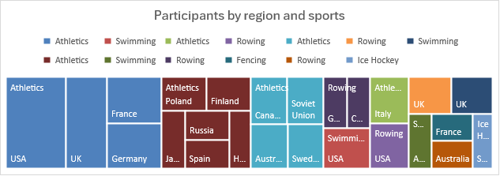

Conclusion:

Sports like Athletics shows more dominance in USA and UK orRowing in Germany

7.Are there any sports that have a higher number of events for one gender compared to others?

Conclusion:

Sports like art competitions ,archery etc has high number of event count in Olympic games.

8.Are there any new events that have been introduced in recent editions of the Olympics?

Conclusion:

Events like speed skationg Men's 500meters speed skating,Lightweight Judo,Men's singleBadminton etc are recently added events In Olympics. These additions aim to enhance diversity, gender balance, and audience engagement, keeping the Games dynamic and modern

9.Are there any events that have been discontinued or removed from the Olympics?

Conclusion:

Several events, such as tug-of-war, cricket, and polo, have been discontinued from the Olympics due to declining popularity, logistical challenges, or lack of global participation. These decisions reflect the evolving focus of the Games on widely recognized and practiced sports.

10.Are there any notable trends in the height and weight of participants over time?

Conclusion:

Line chart shows the variation of height and weight of players over years.

For instance, athletes in sports like basketball and volleyball tend to be taller, while weightlifting shows trends toward higher body weight.

These variations reflect the physical demands and specialization required for different sports.

11. Are there any dominant countries or regions in specific sports or events?

Conclusion:

Countries like USA,UK,France has most dominent in Athelics,Gymnasics,Swimming in Olympics.

USA excels in swimming and athletics, China leads in table tennis and gymnastics, and European nations dominate soccer and cycling.These trends reflect historical, cultural, and resource investments in these sports by respective countries

12.What factors contribute to the success or performance of participants from different countries?

13.Are there any countries that consistently perform well in multiple Olympic editions?

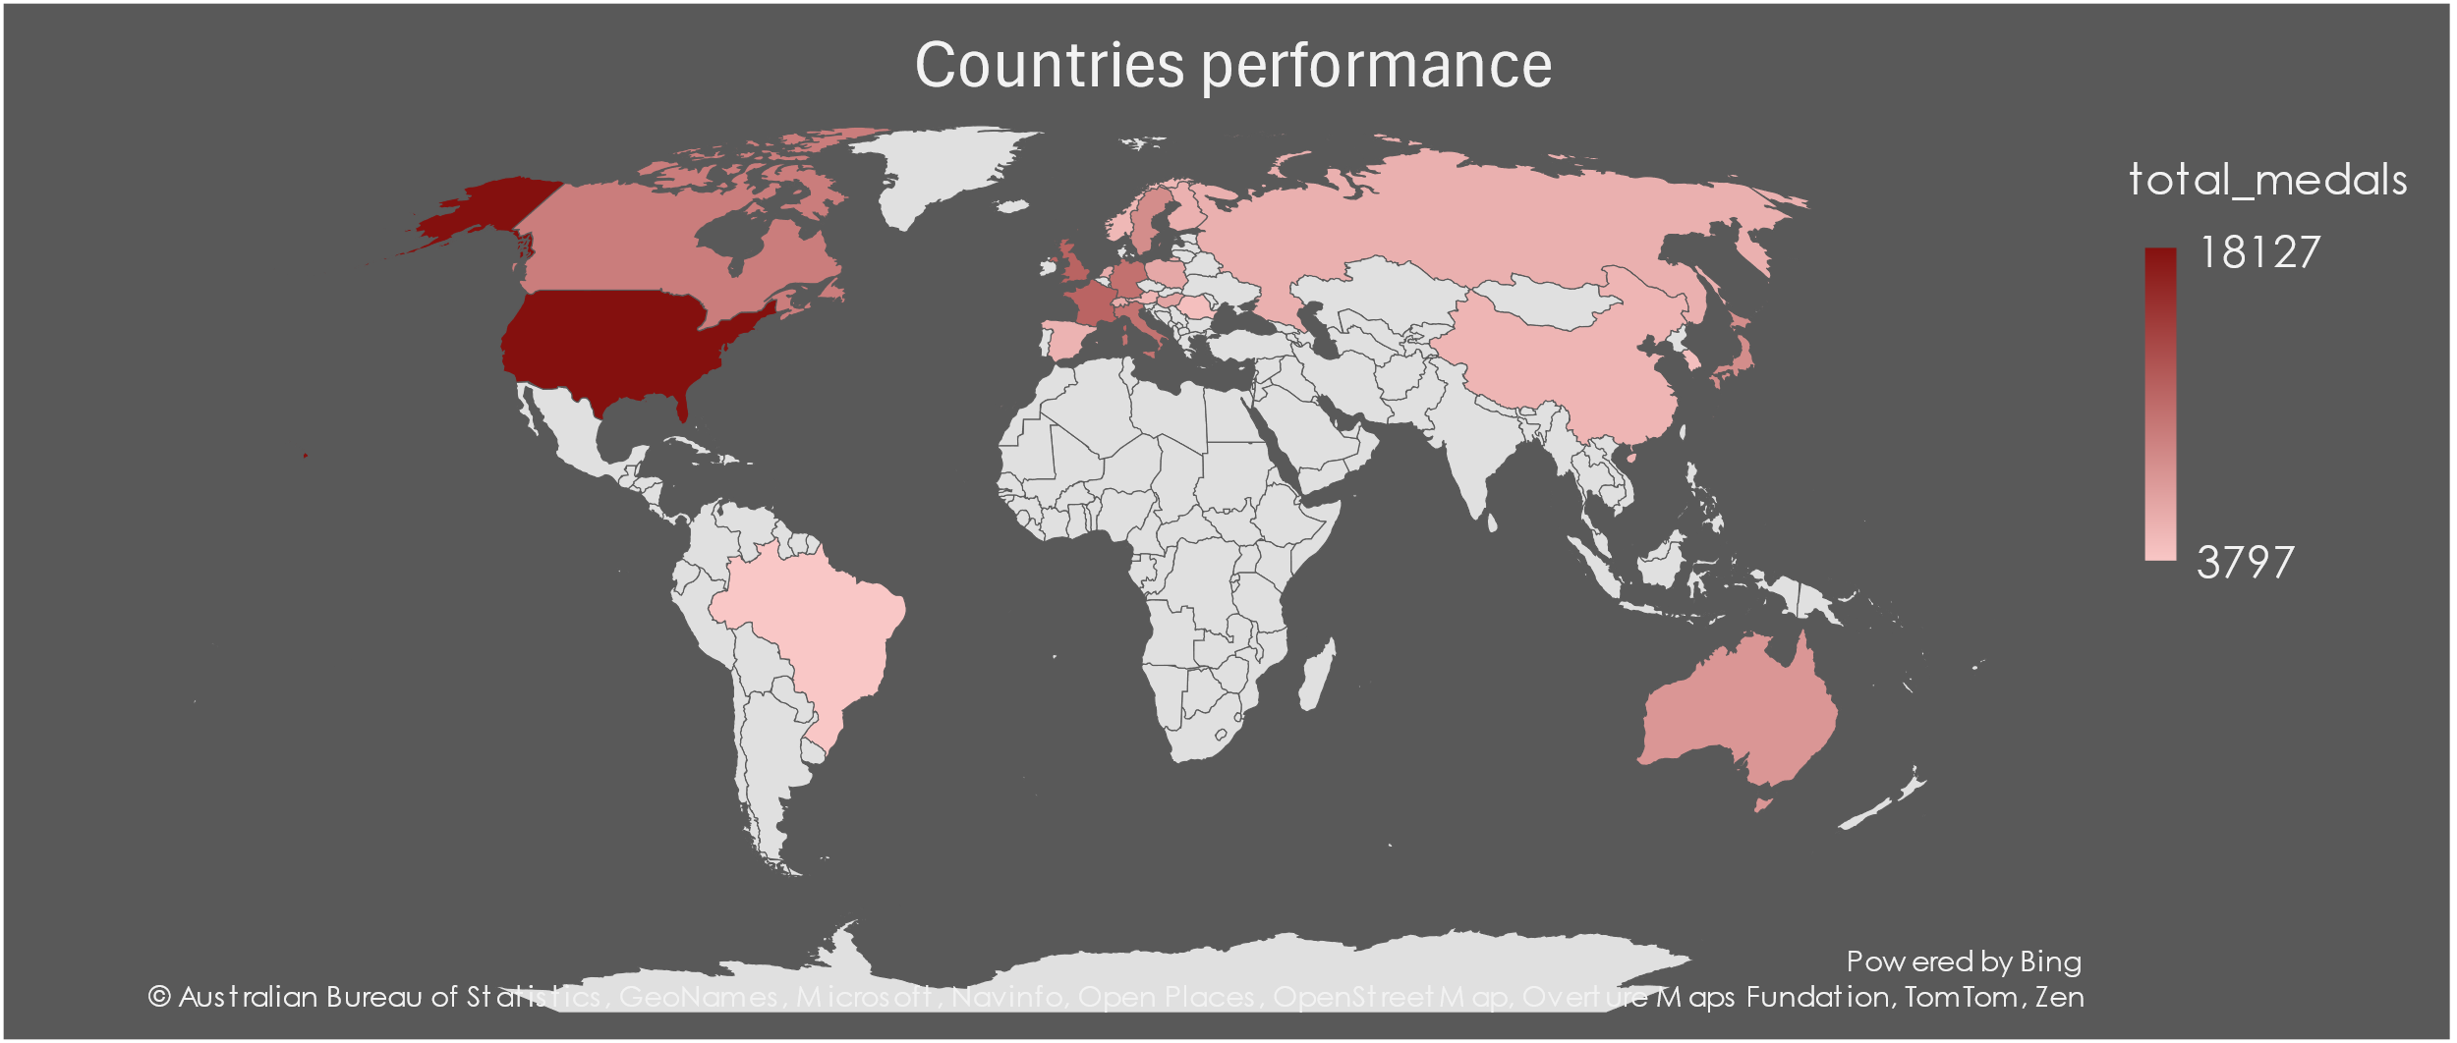

Conclusion:

Countries like USA,UK,France consistently performed well in Olympics.

Their success stems from strong sports infrastructure, investment in athlete development, and diverse participation across various events.

14.Are there any sports or events that have a higher number of medalists from a specific region?

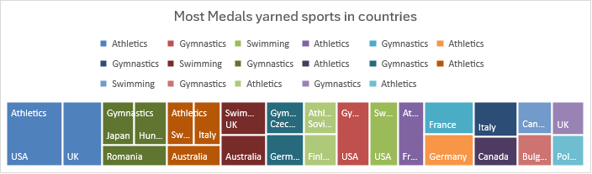

Conclusion:

Athletics in USA and UK earned most medels in Olympics. EDA shows that certain sports have a higher number of medalists from specific regions.

18.Are there any regions that have had a notable impact on the overall medal tally?

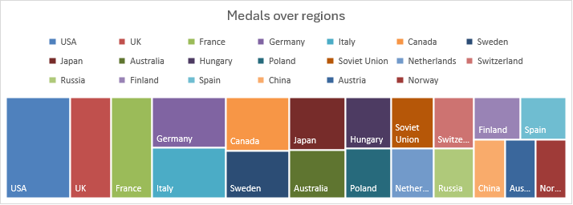

Conclusion:

Countries like USA,UK ,France has high on impact on overall medals tally. Highlight regions that dominate specific sports or decades. Analyze trends over time to see whether any regions are emerging or declining in influence.

**Summary**

This project provides a detailed analysis of Olympic Games data, highlighting trends such as the growth of events, regional dominance, and increasing gender equality. Through interactive dashboards and visualizations, stakeholders can explore:

* Participation trends across decades and regions.
* Medal distribution across sports and countries.
* Gender representation in events and participation.

The project not only uncovers historical patterns but also offers insights into the evolution of the Olympics, making it a valuable tool for researchers, analysts, and sports enthusiasts.

Thank you,

Mohamed Asrar Ali S